Final Project Work
Points possible: 100
Category | Criteria | % of Grade
Functionality | Does the code work? | 25
Organization | Is the code clean and organized? Proper use of white space, syntax, and consistency are utilized. Names and comments are concise and clear. | 25
Creativity | Student solved the problems presented in the assignment using creativity and out of the box thinking. | 25
Completeness | All requirements of the assignment are complete that were committed to for the given week. | 25

Instructions: In Eclipse, or an IDE of your choice, write the code that accomplishes the objectives listed below. Ensure that the code compiles and runs as directed. Take screenshots of the code and of the running program (make sure to get screenshots of all required functionality) and paste them in this document where instructed below. Create a new repository on GitHub for this week’s assignments and push this document, with your Java project code, to the repository. Lastly, in the Learning Management System, click the “Add Submission” button and paste the URL to your GitHub repository.
Coding Steps:
Continue contributing to your final project.

Screenshots of Code:
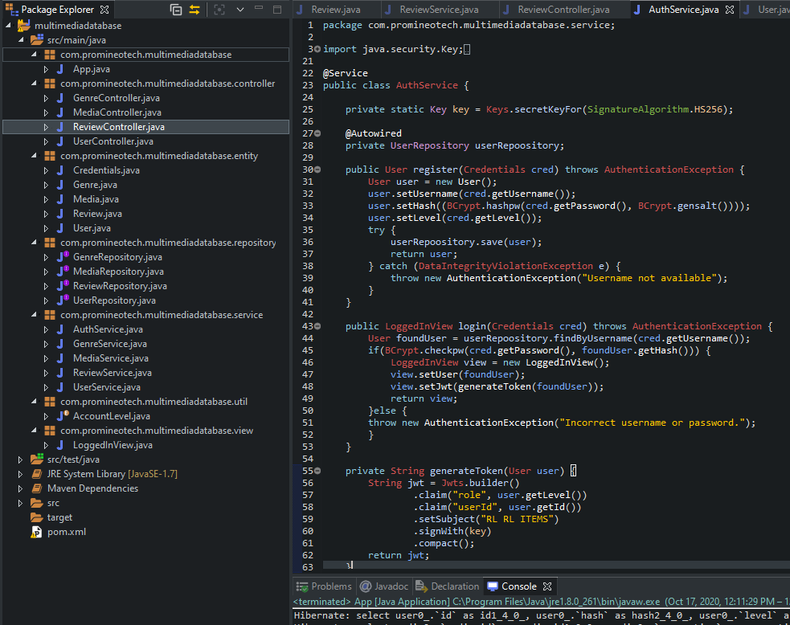

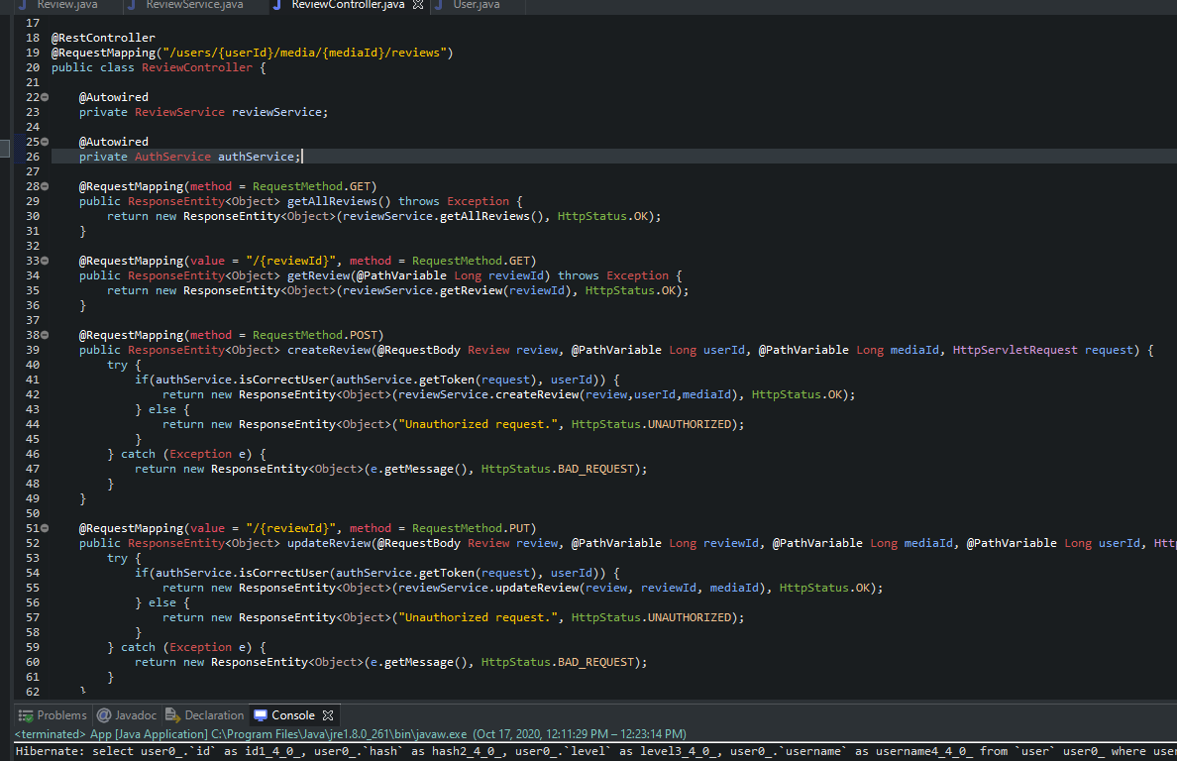

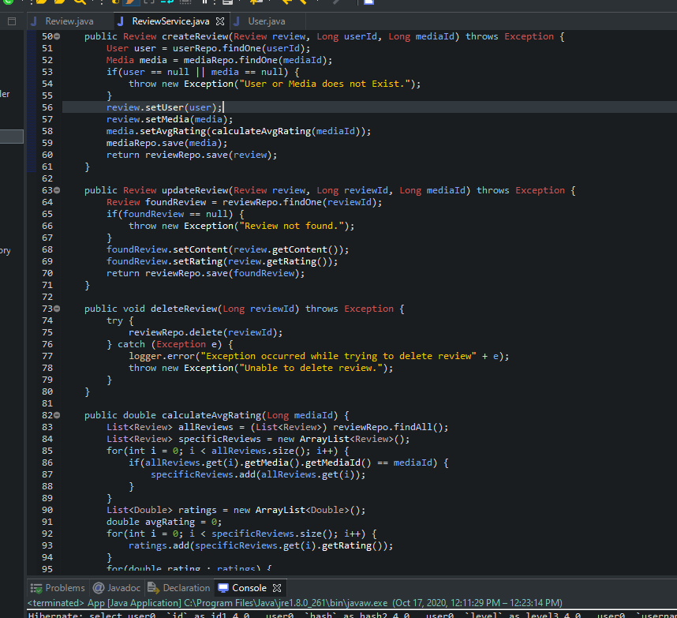

Screenshots of Running Application:
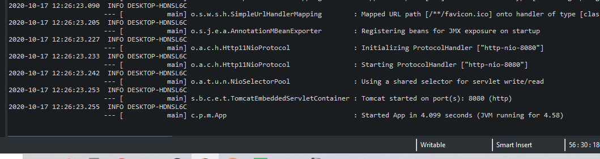
URL to GitHub Repository:
https://github.com/Colin-Cramer/Multimedia-Database/tree/master/src/main/java/com/promineotech/multimediadatabase

